* Setting the adaptor in the

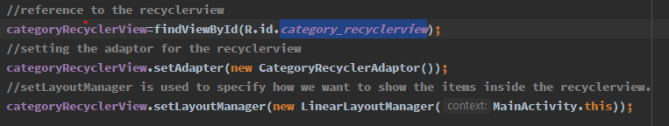

* Declaring the viewholder class

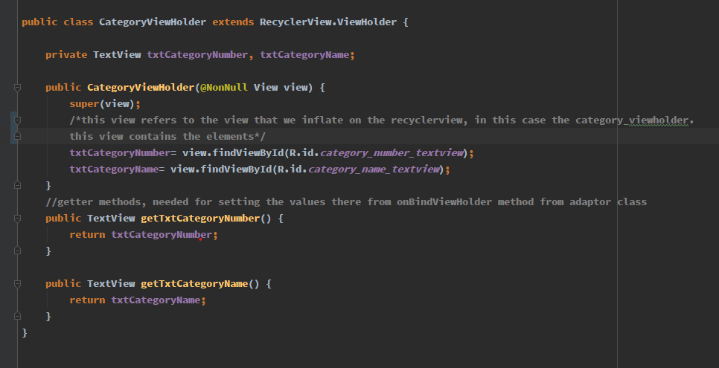

* Delcaring the adaptor class

